**HFCuS**

HaplotypeFrequency

Curation Service

# Input file

ASCII File, XML

## Structure

|  |  |  |  |
| --- | --- | --- | --- |
| Mandatory | XML Tag | Values / Kind of Val. | Description |
| Yes | POP_ID | URI from POP DB | Population Identifier |
| Yes | HT_List | List of HT |  |
| Yes | HTL | Pair of HTL_Name, HTL_Freq |  |
| Yes | HTL_Name | GL String |  |
| Yes | HTL_Freq | 0 < f <= 1 |  |
| Yes | HT_Lic | License ID | License under which HF data is available |
| Yes | HT_Res | G, P, gNMDP, gDKMS, n-Field, Serology |  |
| No | GT_List | List of GTL | List of Genotypes |
| No | GTL | Record of GTL_Name, GTL_M_List |  |
| No | GTL_Name | GL String | Raw Data |
| No | GTL_M_List | List of GTLP_Meth | Additional Information on GT, Typing |
| No | GTLP_Meth | Pair of GTLP_M_Data,  GTLP_M_Value |  |
| No | GTLP_M_TYPE | String | Free Text / Predefined Tag |
| No | GTLP_M_VALUE | Free |  |
| No | GT_Lic | License ID | License under which GT data is available |
| No | METHOD_LIST | List of METHOD |  |
| No | METHOD | Record of METH_Type, METH_Value,  METH_CLASS |  |
| No | METH_Type | String | Free Text |
| No | METH_Value | String | Free Text |
| No | METH_CLASS | String | From predefined list / Text |
| No | QUALITY_LIST | List of QUALITY |  |
| No | QUALITY | Record of QUAL_TYPE, QUAL_VALUE,  QUAL_CLASS |  |
| No | QUAL_TYPE | String | Free Text |
| No | QUAL_VALUE | String | Free Text |
| No | QUAL_CLASS | String | Predefined list / Free Text |
| No | LABEL_LIST | List of LABEL |  |
| No | LABEL | Pair of LABEL_TYPE, LABEL _VALUE |  |
| No | LABEL _TYPE | Free Text | Predefined List and Free Text |
| No | LABEL _VALUE | Free Text |  |
| No | LABEL_CLASS | Free Text | Predefined List and Free Text |
| No | ACL | ToBeDefined  <Defaults to public/private> ?? | Access Control List |
| No | COHORT_ID |  | As an alternative to GT List, NOT THE SAME IDs as used in the HFCeS |
| No | METHOD_ID |  | As an alternative to Method List, NOT THE SAME IDs as used in the HFCeS |
|  |  |  |  |

## Additional Stored Values

* Timestamp
* Submitting UserID

## Direct Output/Feedback

* URI to dataset
* Method_ID
* Cohort_ID
* HF_ID

# Internal Data Structure of HFCuS

## Basic Fields

The basic data structure of the HFCuS mimics the input file

## Additional Fields

To allow for curation of submitted data sets, comments can be used. They are an independent submission to the HFCuS but refer to an existing HF data set. The field COM_REF_SPEC can be used to specifically address a comment to a certain piece of data in the original set.

|  |  |  |  |
| --- | --- | --- | --- |
| Madatory | Data_Field | Content | Description |
|  | COMMENT | Record of COM_TIME, COM_USER, COM_REF_HF,  COM_LIST | Mandatory fields:  COM_TIME, COM_USER, COM_REF_HF, COM_LIST |
|  | COM_TIME | Timestamp | Time of addition of the comment |
|  | COM_USER | UserID | The user of HFCuS adding the comment |
|  | COM_REF | Pair of COM_REF_TARGET, COM_REF_ID | The HF set the comments refer to |
|  | COM_REF_TARGET | Free Text/COHORT_ID, METHOD_ID, HF_ID, POP_ID, COMMENT |  |
|  | COM_REF_ID | ID | Appropriate Of the above target |
|  | COM_LIST | List of COM_REC |  |
|  | COM_REC | Record of COM_TEXT, COM_REF_SPEC |  |
|  | COM_TEXT | Free Text | The comment |
|  | COM_REF_SPEC | Free Text | Some hints what the comment is referring to |

Also, if the genotype list is available, GTs can be downloaded, HF resubmitted for the same Cohort_ID with a different (better!) methodology.

# License Models

People submitting to HFCuS shall choose one of the following options for licensing:

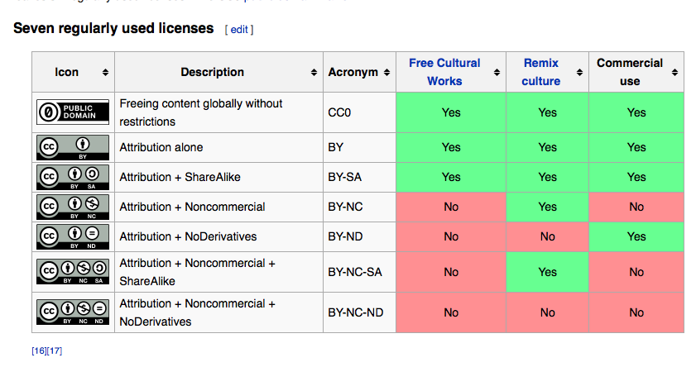

taken from: https://en.wikipedia.org/wiki/Creative_Commons_license

# User and Group Models

TBdone, TBdefined

# List of Method Tags

|  |  |  |
| --- | --- | --- |
| METH_CLASS | HH2016 |  |
| METH_TYPE | **VALUE** | **DESCRIPTION** |
| EM_ALGORTIHM | String | The EM Algorithm used |
| EM_VERSION | String | Version of the EM |
| EM_ALG_REF | String | A reference to the algorithm used |
| MAC_SERVICE | String | The MultiAlleleCodeService used |
| MAC_SER_REF | String | A reference to the MAC Service |
| MAC_VERSION | String | Version of the MAC Service |
| ARS_SERVICE | String | The service used to translate typing resolutions |
| ARS_SERV_REF | String | A reference to the ARS service used |
| ARS_VERSION | String | Version of the ARS Service |
| HWE_METHOD | String | The Method used for HWE deviation estimation |
| HWE_REF | String | A reference to the HWE deviation estimation method |
| LD_METHOD | String | The LD estimation Method |
| LD_METHOD_REF | String | A reference to the LD estimation method |
| EM_PARAM_... |  |  |
| ARS_PARAM_... |  |  |
| HWE_PARAM_.. |  |  |

# List of Geotype-Method Tags

|  |  |  |
| --- | --- | --- |
| METH_CLASS | HH2016 |  |
| GTLP_M_TYPE | **GTLP_M_VALUE** | **DESCRIPTION** |
| TYPING_METHOD | SSO, SSP, Serology, SangerSequencing, NGS,  Free Text | The Typing Method used |
| TYPING_REF | String | A reference to the typing method |
| TYPING_DATE | Date | Date of typing |
| TYPING_IMGT_VER | String | Version on IMGT(/HLA) used to type the sample |
| MIRING_REF | Reference | A reference to a MIRING compliant set of details to the typing of the sample |

# List of Quality Tags

|  |  |  |
| --- | --- | --- |
| QUAL_CLASS | HH2016 |  |
| QUAL_TYPE | **VALUE** | **DESCRIPTION** |
| DIV_LAMBDA | real, < 0 | Exponent of Power law fit to HTF dsitribution |
| DIV_50 | integer | Number of haplotypes needed (in descending order of frequency) to have the cumulative sum be > 0.5 |
| DIV_50_REL | Real, 0 <= x <= 1 | Number of haplotypes needed (in descending order of frequency) to have the cumulative sum be > 0.5 divided by the number of HT |
| SAM_SIZE | integer | Number of GT |
| SAM_POP | integer | Size of Population (approx.) |
| DIV_PGD | Real, 0 <= x <= 1 | Population genetics diversity (1-sum f_i ^2 N/(N-1)) |
| DIV_HEAVY_TAIL | a | Martin knows that |
| RES_TRS_COUNT | Real, 0 <= x <= 1 | Jan knows that |
| RES_TRS | Real, 0 <= x <= 1 | Resolution score |
| RES_SHARE_AMBIG | Real, 0 <= x <= 1 | Fraction of GT with a lower resolution than definied in the resolution tag |
| RES_MISS_LOCI | Real, 0 <= x <= 1 | Fraction of GT with missing loci |
| DEV_HWE | real | Devition from HWE, method described in the method section |
| ERR_STD | Real, 0 <= x <= 1 | Weighted average of standard error |
| ERR_SAMP_80_100 | real | Laurent, Excoffier |
| SUM_FREQ_GAP | Real | Expected but unobserved, LD! |
| ERR_OFFSET | Real, 0 <= x <= 1 | 1-sum f_i |
| LD_MEASURE | real | Define in Method section |
| KFOLD_IMPUTE | real | % of imputable GT from HT |
| KFOLD_PRED_ACTUAL | Real | Divergence between prediction and actual |
| KFOLD_N | integer | Number of independent iterations |

# List of Labels

|  |  |  |
| --- | --- | --- |
| LABEL_CLASS | HH2016 |  |
| LABEL_TYPE | **VALUE** | **DESCRIPTION** |
| GT_REGISTRY | String | ION or other description of the entity hosting the GT |
| HT_ESTIMATION_ENT | String | ION or other description of the entity performed the HTF analysis |
|  |  |  |

# Open Issuses for HFCuS

* User / Group Management, Schema, Specs
* ACL: Management and Specs
* Governance structure
* Implementation

# Images

